RL-R65
RFID Integrated Reader
Software operation manual
Content
1 Software Operation 3
1.1 Set up testing system 3
1.2 Start up test software 3
1.2.1 RS232 Connection 4
1.2.2 RS485 Mode connection 5
1.2.3 Network connection 6
1.3 Set reader parameter 7
2 The reading and writing test for Tag ISO18000-6C 19
2.1 The program for reading and writing 19
2.2 Transparent read the EPC No. 21
2.3 Get EPC No. according to the EPC data 22
2.4 Get EPC No. according to the TID data 24
2.5 Get EPC bank data of the specified tag 25
2.6 Read the TID bank data of specified tag 26
2.7 Read the USER bank data from specified tag 27
2.8 Get PASSWORD bank data from the specified tag 28
2.9 Write to EPC bank 29
2.10 Write to User bank 30
2.11 Modify the PASSWORD of tag 31
2.12 Write protection for EPC-TID -USER bank 32
2.13 Write protection for PASSWORD bank 33
2.14 Write protection for EPC bank 34
2.15 Write protection for USER bank 35
2.16 The data block for USER bank 36
2.17 The read-write protect for PASSWORD bank 38
2.18 Kill tag 39
2.19 Alarm 40
2.20 Set reading protection 43
2.21 Release reading protection 44
3 The reading and writing test for ISO18000-6B tag 46
3.1 Program for reading and writing 46
3.2 Identify all the tag ID 46
3.3 Read data 47
3.4 Write HEX 48
3.5 Write protection 50
4 Auto Test Setting 51

- Software Operation
  - Set up testing system
Connect the equipment as illustrated below, structure a simple reader testing system in the studio:
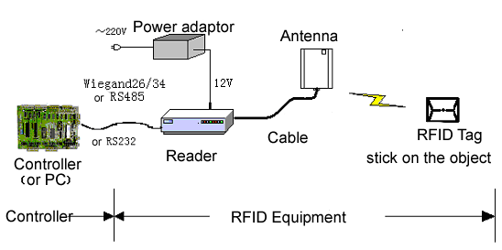
- Connect the reader to PC through the RS232.
- Run the Demo software of the reader on PC, set reader parameters and test reading, writing for the reader according to the notes below.
  - Start up test software
The CD-ROM for RL-R65 contains『application software』Demo.exe, this program needs to be in the running in under the environment of Microsoft Windows XP or higher version or the operating system IBM pc-compatible computers. Run Demo. exe to start this software.
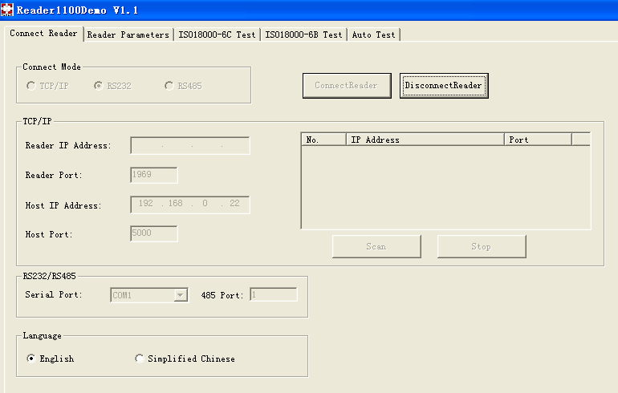
    - RS232 Connection
Computer can communicate with reader through serial port (RS232). The User need to to do initialized Settings through a serial port when start to set the reader, like set IP address to connect to network.
- Select the output port, see below.
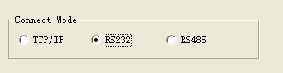
- Select the serial port for reader and PC.
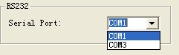
- Click『ConnectReader』button, if connected success, Popup the following clew box.
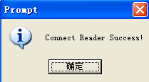
- If no reader connected to PC through this serial port, or the selected serial port is wrong, the connection will fail, Popup the following clew box.
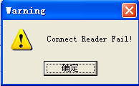
    - RS485 Mode connection
Computer can implement data exchange with reader through RS485 port.
- Select the output port, see below.
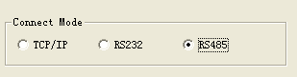
- Select the serial port for reader and PC.
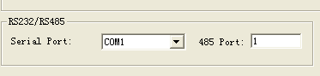
- Click『ConnectReader』button, if connected success, Popup the following clew box.
- If no reader connected to PC through this serial port, or the selected serial port is wrong, the connection will fail, Popup the following clew box.
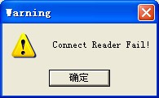
    - Network connection
Upper Computer can implement data exchange with reader through（TCP/IP）.
- Select the network connection mode, see below.
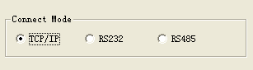
- Select the reader IP address from the below clew box.
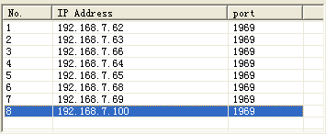
- Or input the IPAddress of Reader and Port of Reader diredtly,as below;
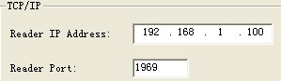
- Click『ConnectReader』button, if connect success, popup the below clew box.
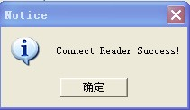
- If the reader disconnected to PC through RJ45 port, or the the inputted IP information is wrong, the connection will fail, Popup as below
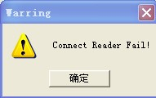
- When the user not sure the IP address , chick “Scan”, the matched IP are listed :
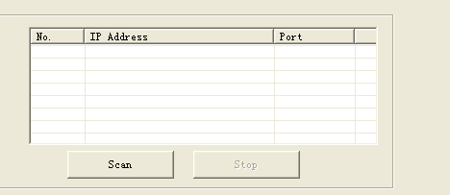
  - Set reader parameter
Below is the operation page for setting parameter for RL-R65-
『Reader parameter』:
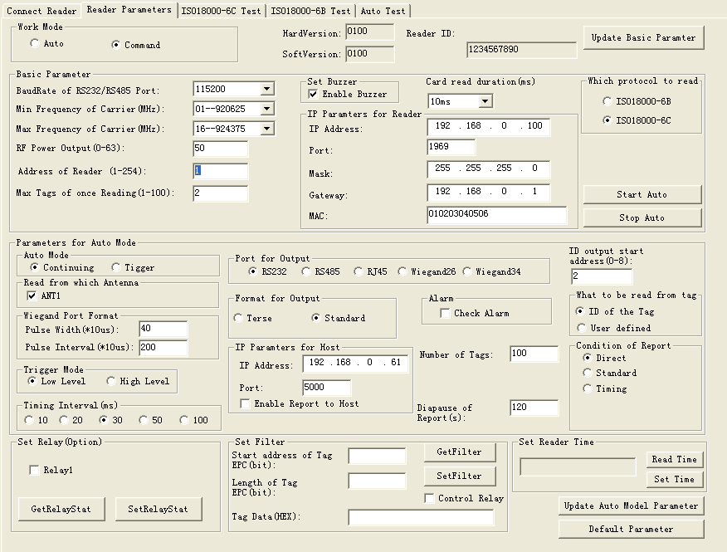
- Select Operation Mode
There are 2 modes for RL-R65 as below:
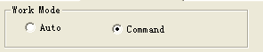
- Command: readers begin to work after receive legal control command through RS232 or RS485, and return the command results through that port.
- Auto: the reader read tags automaticly and interval,and output the reading results through setting port (Wiegand and RS485 or RS232) when successful. No ourput If read fail or read illegal tag (need validation) .
Remarks:
- Command mode is default setting, unless the user select Timing mode when run the reader
- Reader no response any instruction in Command work mode, unless below :
1: Get Version number 2: Set working status (start or stop auto mode) 3: Clear memory 4: Read the record 5: Update 6 reset.
- should select “stop Auto” so that get to command mode or run other else setting when in Auto mode
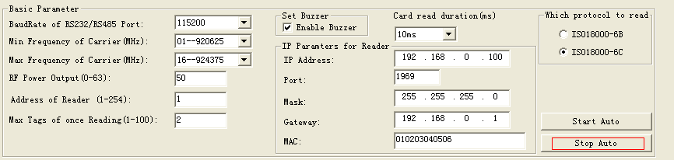
- Basic Parameters
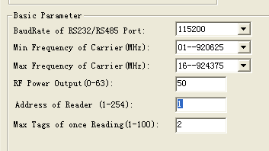
No matter in which operation mode, The user need to set 4 parameters as below
- Baud Rate of RS232/485 Port: set communication rate of RS232 and RS485 port, 9600, 19200, 38400, 57600, 115200bps option
- Max Tags of once Reading: Set the MAX number of labels to read at one time. The quantity on Max Tags of once Reading is according to the requirements. And the less the reading race fast.
- RF Power Output: output power for the reader. Usually this param has been set to the optimal before EX-factry. If the profermance is good, please don’t modify this param.
- Min. Frequency of Carrie): set the min operation frequency for the reader.
- Max. Frequency of Carrier: set the max operation frequency for the reader.
For different countries or regions, there are corresponding choices in the listed working frequency based on local radio rules requirement. Users can choose sensitive frequencies according to local conditions. If choose a Fixed Frequency point, set the Min. Frequency equel same as to Max.Frequency; If Frequency hopping, can choose the Min. Frequency of Carrier for fmin, Max.Frequency of Carrier for fmax, as long as fmax > fmin. As below:
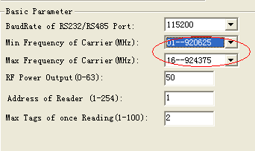
- Setting buzzer:
Close buzzer, the buzzer don’t sound when identified tags, only tag information displayed on the PC
Open the buzzer, the buzzer sound when identified tags, and tag information displayed on the PC
- Card read duration(ms)
10,20,30,40 ms option, the longer the less miss-reading
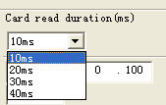
RS485 network: Can make networking through RS485. The user need to set an address for each reader before make networking, and enable the reader can connect with PC through TCP/IP. Address range: 1 to 254.
Remarks: 1 and 254 are broadcast address，all readers will return application information after receive command with broadcast address.
- Which protocol to read( ISO18000-6B,6C option)
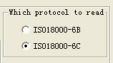
- Set network parameter
The used should set the network parameter when connect the reader to PC by TCP/UDP.
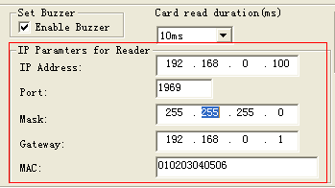
Remarks: The repeated MAC address is no permit
- Set Relay (Option)
- Relay work: Check Relay1 and Chick SetRelayStay
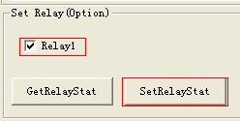
- Relay work off: No check Relay1
Remarks: Relay is option function, parts readers without this function
- Auto Mode Parameters
- Working process
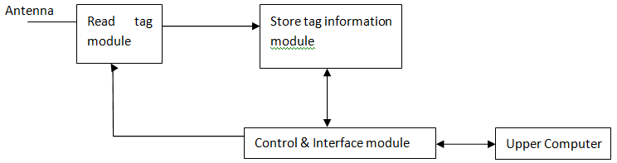
- Read tag module: In Charge of Reading only, Timing or Triggering work way option. The User can set on Interval of reading,Reading from which Antenna, Triggering level,which tyre of tag to be read
- Store tag information module: In charge of Store read-tag information, such as the reading time, store capacity.
- Control & Interface module: Manage the process of reading and exchange date with Upper computer.
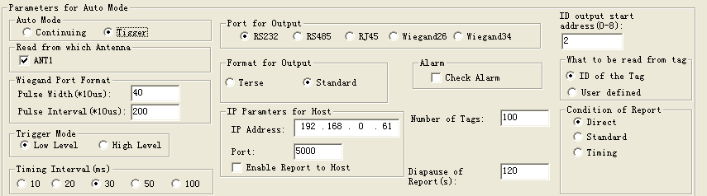
- Work way: Continuing or Tigger
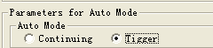
- Continuing: the reader read tags in interval, and output the reading results through setting port (Wiegand and RS485 or RS232) when successful. No output If read fail or read illegal tag (need validation) .
- Trigger: reader detects signal variation on FIN1 pins automaticly, when detect low electricity at ordinary times; reader starts to send a signal, read label numbers. When FIN1 pins in high level, stop reading card. The readed card number output through the setted data port. If read invalid card, then output 0xffffffff. There are 2 modes: Low Level or High Level
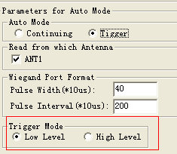
- Reading from which antenna : Only ANT1
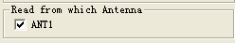
- Port for Output
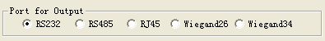
Remarks: If output is Wiegand, interval is 1s for output Tag ID
- Wiegand output format
3 output forms on Pulse Width & Pulse Interval .Pulse Width IS 40 and Pulse Interva is 200 are default setting.
Pulse Width | Pulse Interval | Output waveform Pulse Width | Output waveform Pulse Interval
40 | 200 | 400us | 2ms
10 | 160 | 100us | 1.6ms
5 | 100 | 50us | 1ms

- ID Output start address (0-8)
It is for tag ID, there is 8Bytes on Tag ID, address0-8
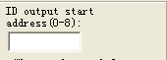
- The relationship among ID Output start address, tag protocol ,output ID (output is Wiegand 26)
ID Output start address | ISO18000-6C  (112233445566778899001122) | ISO18000-6B  (E0044BDF23010000)
0 | 223344 | 044BDF
1 | 334455 | 4BDF23
2 | 445566 | DF2301
3 | 556677 | 230100
4 | 667788 | 010000
5 | 778899 | Unuseble
6 | 889900 | Unuseble
7 | 990011 | Unuseble
8 | 001122 | Unuseble
- The relationship among ID Output start address, tag protocol ,output ID (output is Wiegand 34)
ID Output start address | ISO18000-6C  (112233445566778899001122) | ISO18000-6B  (E0044BDF23010000)
0 | 22334455 | E0044BDF
1 | 33445566 | 044BDF23
2 | 44556677 | 4BDF2301
3 | 55667788 | DF230100
4 | 66778899 | 23010000
5 | 77889900 | Unuseble
6 | 88990011 | Unuseble
7 | 99001122 | Unuseble
8 | 00112200 | Unuseble
- The relationship among ID Output start address, tag protocol ,output ID (output is RS232,485)
ID Output start address | ISO18000-6C  (112233445566778899001122) | ISO18000-6B  (E0044BDF23010000)
0 | 112233445566778899001122 | E0044BDF23010000
1 | 112233445566778899001122 | E0044BDF23010000
2 | 112233445566778899001122 | E0044BDF23010000
3 | 112233445566778899001122 | E0044BDF23010000
4 | 112233445566778899001122 | E0044BDF23010000
5 | 112233445566778899001122 | E0044BDF23010000
6 | 112233445566778899001122 | E0044BDF23010000
7 | 112233445566778899001122 | E0044BDF23010000
8 | 112233445566778899001122 | E0044BDF23010000
- What to be read from Tag:
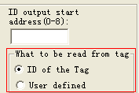
The User take UID number as tag ID general, sometime User define ID and take it due to Project requirement, especially in Access control case.
 | ISO18000-6C | ISO18000-6B
ID of the Tag | EPC | ID
SN Written by User | TID | The data from 220～223 of user
- The relationship among output form, output tag ID bits and and tag protocol.
 | ISO-18000-6C | ISO18000-6B
RS232/485/RJ45 | All EPC bits | All ID bits
wiegand 26 | The operating param 『initial address of output card』determin output 32bits of 64 bits ID | The operating param 『initial address of output card』determin output 24bits of 64 bits ID
wiegand34 | The operating param 『initial address of output card』determin output 32bits of 64 bits ID | The operating param 『initial address of output card』determin output 32bits of 64 bits ID
- Format for Output
Two ourput formats: Terse or Standard: Appendix A with destription
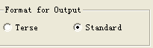
- Timing Interval: 10,20,30,50,100ms option, due to the object speed,
The fast the interval short
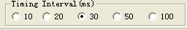
- Alarm:
Check Alarm in Auto work mode, that the read should check Alarm status before reading Tag EPC, If alarm, the relay closing for 4ms
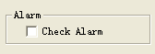
- IP Paramters for Host
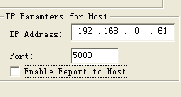
The reader transfer tags ID to upper PC in Auto mode, so the IP Address of upper PC need to be setted
Remarks: Check “Enable Report to Host” means the reader output 00000000 EPC ID to upper pc if read nothing in Fixed time
- Condition of Report: the output tad ID way in Auto mode
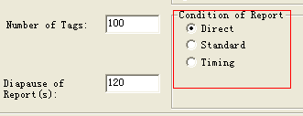
- Direct: output ID once read
- Standard: Tag ID output in interval on read frequently, difference ID output immediately
- Timing: read tag ID in interval, output the IDs once read,no matter recorded it before
- Number of tags : the max quantity of store tag ID which be read. If the quantity more than Max, the earlies record is instead by last one
- Diapause of reports:How long the read transfer the tag ID to upper PC
Remarks: the “Dispaude of reports” is workable in “Standard” or “Timing” report
- Set Reader Time
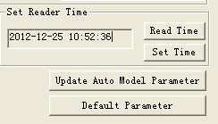
- Read time : Upper PC get the what time of read
- Set time: Upper PC update the time to read
- Set Filter: Reader identify the coincident tags base on Filter
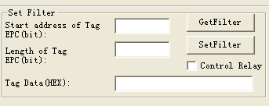
1; Start address of tag EPC, Bit unit, Such as 6
2: Length of Tag EPC, Bit unit, Such as 3
3: Tag data (hexadecimal): Such as 4
The setting is for continuous bit in tag ID, All coincident tags be red,
When the coincident Tag EPC NO.length is not on a multiple of 4 bits, fill 0 for completely. Such as EPC 053000000000000000000000 and FD7000000000000000000000 are both coincident tags, should be read.
Remarks: if ask to Aralm when read the coincident tag, check “Relay 1”
- Update Basic Paramter : for update the Basic Paremeter

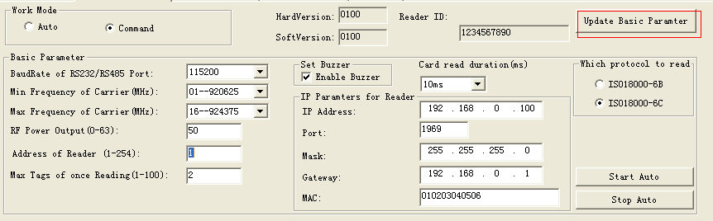
- Update Auto Model Paramter: for update the Auto Paramter
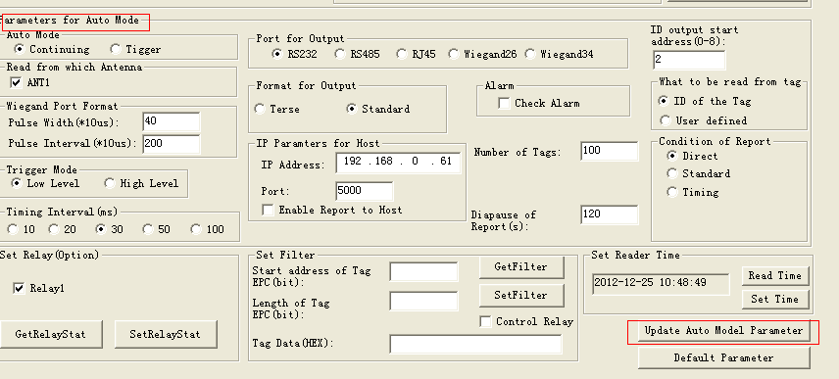
- Default Paramter: Back to the default Paramter
- The reading and writing test for Tag ISO18000-6C
  - The program for reading and writing
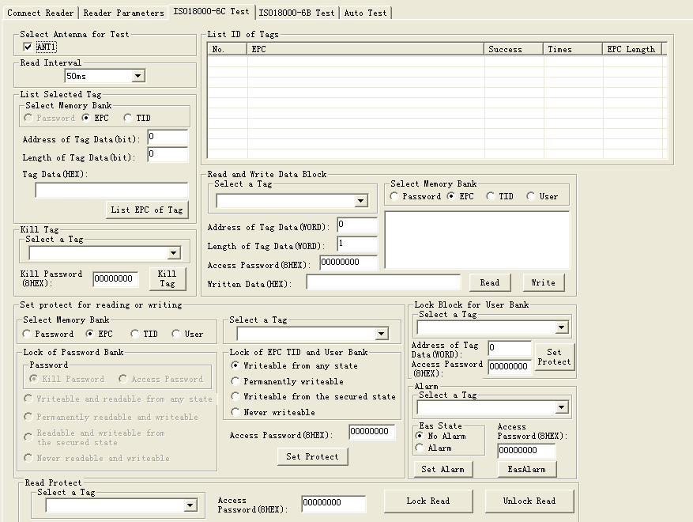
- The storage of tag ISO18000-6C.
Four partitions:
- EPC: for storage EPC code, it can store 96bits EPC code at most. Read & write.
- TID: area for storage the ID number setted by the factory, have two kinds of ID number 32 and 64 bits at present. Read Only
- User: Each company has a rule.
- Password: 32bits access password and 32bits kill password. Read & write.
The four partitions are all with write proction. Write protection means unwriteable when in unsate situation or never writeable Read protection means unreadable on the password Partition
- The reading and writing process for ISO180000-6C tag.
  - Selection: select a partition From 4 Partitions,then select tags according to specified data in this partition.
  - Inquiry tag one by one: identify all the tags one by one based on the selection.
  - Access: access an identified tag. Such as read& write the four partition, set read write protection and modify password
- Tips:
  - 『No Tag!』: read nothing
  - 『The memory isn’t exist』store memory is not exist
  - 『The memory has been protected』
  - 『Power is not enough』
  - 『Password is error』
  - 『Write Fail！』
  - 『Write Successfully』
- Set antenna.
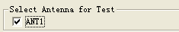
- Set interval
The reading interval can select from:10、20、30、50、100、200 ,and 500ms,default is 50ms.
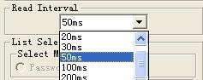

2.2 Transparent read the EPC No.
Operating steps are as below:
Firstly, select any bank except the password bank, such as EPC bank, see below:
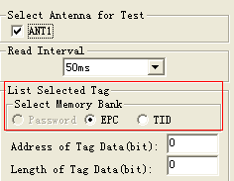
Secondly, set the initial address of data bank to be zero, 0 represents identify all the tag in transparent. as below:
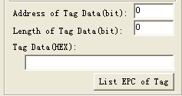
Thirdly, click 『identify tag』button, reader get EPC Number Based on the second step. The identified EPC No. showed in the top right corner『show identified tag ID』dialogue frame.
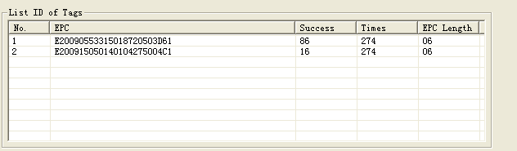

2.3 Get EPC No. according to the EPC data
According to the specific data segment in EPC bank, choose tags meet the condition, read the EPC number.
Operating steps are as below:
Firstly, select any bank except password bank, such as EPC bank, see below:
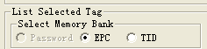
Secondly, set the 『initial address of data』 bank, unit with Bit, the start address only should be whole number Such as the 12.
Thirdly, set the『 length of the data』, unit by Bit, such as 3.
Fourthly, select 『Tag data (HEX)』 for the unit, such as 4, see below. Here the so-called conditions is aimed at a regional data in some tags consecutive patients (bit), who meet the conditions of the tag will be read. The length of the conditional values is not mulriple 4Bits, low fill 0.
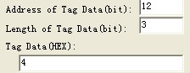
Fifthly, press "identification tag" button, reader began to read the label EPC number according to the first four steps setted conditions. Illustrate: see chart 5.1, radiation field have eight tag, if have to meet the conditions: data area initial address is 12, the data length is 3 (namely needs to compare three), selected data is C, the only one card whose ID 5555555555555555555555 meet, and list to show, see figure 4.3 (because the start bit of card id 12, need to compare the condition of the length is 3, if meet conditional values for hexadecimal 4 or 5 (010 low fill a zero convert 0100 or 0101). Be identified label’s EPC number displayed in the upper-right corner "show identified label ID" as below:
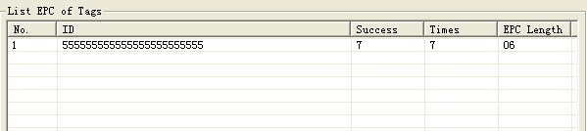

2.4 Get EPC No. according to the TID data
Read the coincident EPC number as to TID Bank
Operation steps are as below:
Firstly, select any bank except the password bank, such as TID bank, see below:
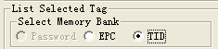
Secondly, set the『address of Tag data』bank, unit with bit, the start address only should be whole number. For example: 43.
Thirdly, set the『 length of Tag data』, unit by bit, such as 4.
Fourthly, select data choose HEX for the unit, such as 4, see below. Here the so-called conditions is aimed at a regional data in some tags consecutive patients (bit), who meet the conditions of the tag will be read. The length of the conditional values is not mulriple 4bits, low fill 0.
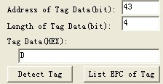
Fifthly, press『List EPC of tag』button, reader began to read the label EPC number according to the first four steps setted conditions. Illustrate: see chart 5.1, radiation field have eight tags, If have to meet the conditions: data area initial address is 43, the data length is 4 (namely needs to compare 4), selected data of D, only card whose ID is 3005FB63AC1F3841EC885555 TID area for E2006004009AE045 meet the condition, and then showed as below:
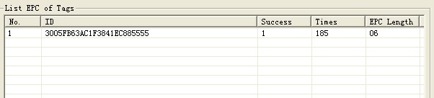

2.5 Get EPC bank data of the specified tag
EPC bank of ISO18000-6C tag have three parts, sequence is as follows:
- CRC-16 is PC value and the redundancy circular check code of EPC No, CRC are 16bits, is the BF50H in the picture.
- PC comperent from the length of EPC No. and application code.The length of PC value is 16bits, is the 3000H in picture.
- EPC is EPC No. Picture as below: E200H (the first character of EPC No.).
Can read any EPC block data, operating steps are as below:
The first step, select EPC storage area, as below:
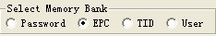
The second step, select tag, for example『E20090553315018720503D61』, as below:
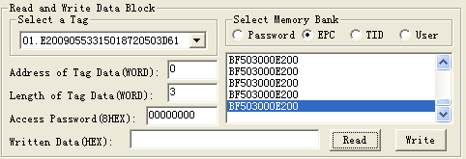
The third step, select the start『 address of Tag data』, unit by word, such as 0,
The fouth step, set the『length of the tag』, unit by word, such as 3,
The fifth step, press『read』button, reader began to read the label EPC number according to the first four steps setted conditions. The data displayed in the upper-right corner.
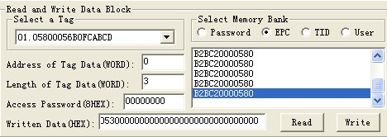

2.6 Read the TID bank data of specified tag
Can read any TID block data, operating steps are as below:
The first step, select TID storage area, as below:
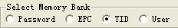
The second step, select tag, for example『E20090553315018720503D61』, as below:
The third step, select the start『address of Tag data』, unit by word, such as 0, as below:
The fouth step, set the length of the tag, unit by character, such as 3, as below:
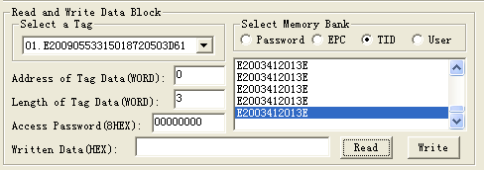
The fifth step, press『read data』button, reader began to read the label TID number according to the first four steps setted conditions. The data displayed in the upper-right corner.

2.7 Read the USER bank data from specified tag
Can read any USER block data, operating steps are as below:
The first step, select USER storage area, as below:
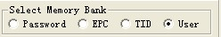
The second step, select tag, for example『E20090553315018720503D61』, as below:
The third step, select the『address of Tag data』, unit by word, such as 0, as below:
The fouth step, set the『length of tag Data』, unit by word, such as 3, as below:
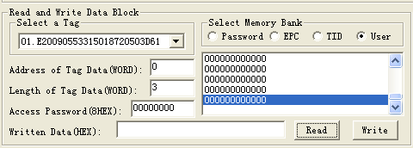
The fifth step, press『read』button, reader began to read the label USER number according to the first four steps setted conditions. The data displayed in the upper-right corner.

2.8 Get PASSWORD bank data from the specified tag
If the password does’t be read protection, it can read any password block data; the password bank has two parts as below:
(1) Kill password: 32bits
(2) Access password: 32bits
Operating steps are as below:
The first step, select password storage area, as below:
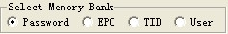
The second step, select tag, such as 『777777777777777777777777』, see below:
The third step, select the 『address of Tag Data』, unit by word, such as 0, as below:
The fouth step set the『 length of tag Data』, unit by word ,such as 4, as below:
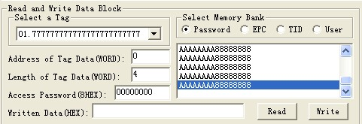
The fifth step, press『read data』button, reader began to read the label USER number according to the first four steps setted conditions. The data displayed in the upper-right corner. AAAAAAAA is kill password, 88888888 is access password.

2.9 Write to EPC bank
Can write16、32、48、64、80 or 96bits EPC No. to the EPC bank at present. CRC-16 and PC value automatic generation according to written EPC. The operation steps are below:
The first step, select EPC storage area, as below:
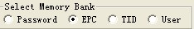
The second step, set the EPC No. length, such as 6, means 9bBits, as below:
The third step, if the EPC bank has been set password lock, should fill『Access password』, such as 88888888, see as below:
The fourth step, fill EPC No. to 『writen data (HEX)』, united by HEX,such a『45679464ABCDABCD35467684』.
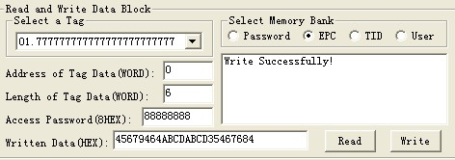
The fifth step, press『write data』button, reader began to write the label EPC data according to the first four steps setted conditions. The written data displayed in the upper-right corner.
The sixth step, get EPC No., check if the written right or not.
Remarks:
- Put only a tag in the write radio frequency, otherwise, several tags may all writed the same EPC No. As write EPC No. don’t choose a specified tag, so don’t have to choose『select a tag』.
- All EPC No. are write from address 0, reader don’t identify『address of Tag data』.
(3) When the written data more than 2 Bytes, show wrong information, may only partial data has been written wrong.

2.10 Write to User bank
The operation steps as below:
The first step, select USER storage area, as below:
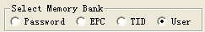
The second step, select a tag, such as『45679464ABCDABCD35467684』, see as below:
The third step, select the initial address of user bank, such as 0, see as below:
The fourth step, set the length of data, such as 4, see as below:
The fifty step, if the user bank has been set password, then has to fill the『Access password』, such as 88888888 see as below:
The sixth step, fill data to『written data(Hex.)』, such as『1234567891234567』.
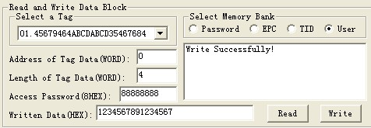
The seventh step, press『writte』button, reader began to write the label USER data according to the first four steps setted conditions. The written data displayed in the upper-right corner.
The eighth step, get USER Data, check if the written right or not.
Remark: When the written data more than 2bytes, show wrong information, may only partial data has been written wrong.

2.11 Modify the PASSWORD of tag
The operation steps are as below:
The first step, select password storage area, as below:
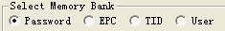
The second step, select a tag, such as『45679464ABCDABCD35467684』, see as below:
The third step, select the initial address of user bank, such as 0, see as below:
The fourth step, set the length of data, such as 2, see as below:
The fifty step, fill the『Access password』, such as 88888888, see as below:
The sixth step, fill new password to『written data(Hex.)』, such as『AAAAAAAA』.
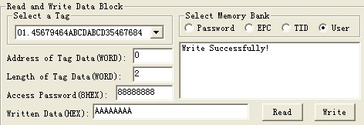
The seven step, press『write data』button, reader begins to write password according to the condition set be the above sixth step, such as write kill the tag. The written data displayed in the upper-right corner.
The eighth step, get new password, check if the written right or not.
Remark: When the written data more than 2bytes, show wrong information, may only partial data has been written wrong.

2.12 Write protection for EPC-TID -USER bank
The TID bank of ISO18000-6C tag is locked and be readable only.
There is protection for reading on EPC bank and USER bank of ISO18000-6C tag , but write, the write protection as below:
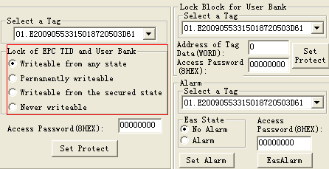
Writable from any state- can write without password, and can set to permanently writable, Writable from the secured state or Never writable in the future.
Permanently writable- can write without password, and can’t set to be Writable from the secured state and Never writable;
Writable from the secured state- only can write with the password, and can set to permanently writable, Writable from the secured state or Never writable in the future.
Never writable-can’t write even with password.

2.13 Write protection for PASSWORD bank
The password of ISO18000-6C tag can be read and write proteted, the password situation wouldn’t effect use the password. Protection function:
Readable and Writable from any state- can read and write without password, and can set to permanently Readable and writable, Readable and Writable from the secured state or Never reader or writable in the future.
Permanently readable and writable- can read and write without password, and can’t set to be readable or Writable from the secured state and Never readable or writable;
Readable and Writable from the secured state- only can read orwrite with the password, and can set to permanently readable and writable, readable and Writable from the secured state or Never readable or writable in the future.
Never readable or writable-can’t read or write even with password.
Remarks: set read write protect for tag, should know the access password of tag in advance.

2.14 Write protection for EPC bank
The first step, select the EPC bank, as below:
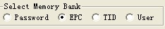
The second step, select a tag, such as『45679464ABCDABCD35467684』,as below:
The third step, select the Writable from the secured state (or Writable from any state, or permanently writable or never writable), as below:
The fourth step, fil the l『access password』,the access password for tag『45679464ABCDABCD35467684』is 88888888, see as below:
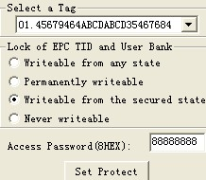
The fifth step, press『set protecting』button, popup the below dialogue box:
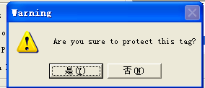
The sixth step, press『no』, then the above operation invalid, press『yes』,according to the before four step setted condition, if success, popup the below frame, represents the EPC bank has set to be password lock.
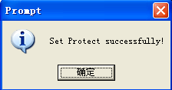
The seventh step, write data to EPC bank, check if the set protection suceess or not.

2.15 Write protection for USER bank
The first step, select the USER bank, as below:
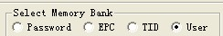
The second step, select a tag, such as『45679464ABCDABCD35467684』, see as below:
The third step, select the Writable from the secured state (or Writable from any state, or permanently writable or never writable), as below:
The fourth step, fill the l『access password』,the access password for tag『45679464ABCDABCD35467684』is 88888888, see as below:
The fifth step, press『set protect』button, popup the below dialogue box:
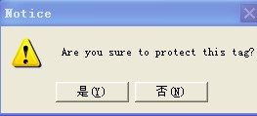
The sixth step, press『no』, then the above operation invalid, press『yes』,according to the before four step setted condition, if success, popup the below frame, represents the EPC bank has set to be password lock.
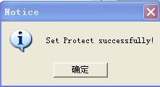
The seventh step, write data to USER bank, check if the set protection suceess or not.

2.16 The data block for USER bank
Only the SL3-ICS-10 UCODE EPC ISO18000-6C tags from NXP provide this kind of lock. Each block has 32bits (4bytes or 2 words). Once the block has been locked, it can’t be modified forever.
The first step, select a tag, such as『45679464ABCDABCD35467684』, see as below:
The second step set the data address, such as 6 or 7, will protect 6 and 7two words as below. The SL3-ICS-10 tag has 14 Words at present,the address is 0～13.
The initial addres(word) | The data been protected (word)
0 or 1 | 0 and 1
2 or 3 | 2 and 3
4 or 5 | 4 and 5
6 or 7 | 6 and 7
8 or 9 | 8 and 9
10 or 11 | 10 and 11
12 or 13 | 12 and 13
The third step,fill the access password, the access password of tag『45679464ABCDABCD35467684』is 88888888, see as below:
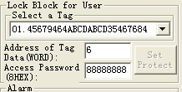
The fourth step, press『set protect』button, popup the below dialogu box:press『yes』button, the reader will send block lock command to the tag, if success, PC will popup the below frame.
Set protect success or not, operate to check it.
If fialed, will popup error information.

2.17 The read-write protect for PASSWORD bank
The first step, select the user bank, see below:
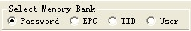
The second step, select the access password (or kill password), see as below:
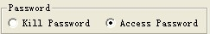
The third step, select a tag, such as『45679464ABCDABCD35467684』, see as below:
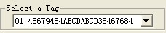
The fourth step, select the Readable and Writable from the secured state (or Readable and Writable from any state, or permanently readable and writable or never readable or writable), as below:
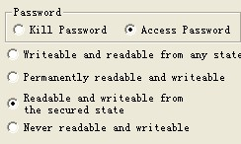
The fifth step, fill the『access password』, the access password for tag『45679464ABCDABCD35467684』is 88888888, see below:
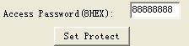
The sixth step, press『set protect』button, popup the below frame:
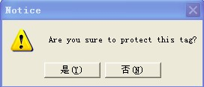
The seven step, press『no』, then the above operation invalid, press『yes』,according to the before four step setted condition, if success, popup the below frame, represents the USER bank has set to be password lock.
The eighth step, write data to USER bank, check if the set protection suceess or not.

2.18 Kill tag
Caution: Once the tag has been killed, it does not answer the reader ever.
The first step, select a tag『Select a Tag』, such as『222222222222222222222222』, see below:
The second step, fill the kill password to『Password』(HEX), the kill password of tag『222222222222222222222222』is 00000000, see as below；
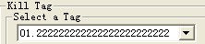
The third step, press『Delete Tag』button, popup the below frame:
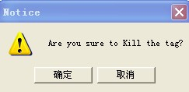
The foutth step, press『no』, then the above operation invalid, pres『yes』,according to the before three step setted condition, if success, popup the below frame, represents the tat has been killed.
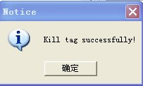
The fifth step, read the EPC No. to check if killed the tag successful or not.

2.19 Alarm
Only the NXP SL3-ICS-10 UCODE EPC ISO18000-6C tag is with Alarm function, this function is similar to the barcode used in library and supermarket. Alarm is ring when the tag on the goods is under the alarm situation and be read.
- Set alarm status
The first step, select a tag, such as『45679464ABCDABCD35467684』, as below:
The second step, fill the access password, Hex., the access password of tag『45679464ABCDABCD35467684』is 88888888, as below:
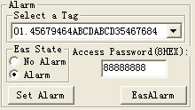
The third step, select 『alarm』
The fourth step, press『set alarm』button, reader send set alarm command , if success, popup the below frame:
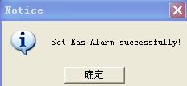
If failed, popup popbox, the failure reason may be the reader left the radio frequency or the access password is wrong.
Check if set alarm successfully.
- Set no alarm
The first step, select a tag, such as『45679464ABCDABCD35467684』, see as below:
The second step, fill the access password, Hex., the access password of tag『45679464ABCDABCD35467684』is 88888888, see as below:
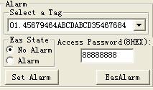
The third step, select 『no alarm』
The fourth step, press『set alarm』button, reader send set alarm command to tag, if success, popup the below frame:
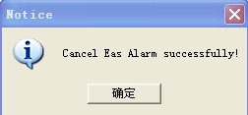
If failed, popup popbox, the failure reason may be the reader left the radio frequency or the access password is wrong.
Check if set no alarm successfully.
- Check alarm
Press『EasAlarm』button, reader send check alarm command to tag. If found some tags are in the alarm situation, the buzzer will alarm, and there would be red light twinkle on the PC interface.
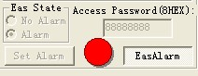
If foud no any tag under the alarm situation, buzzer will not alarm and there no tips on the PC.
Once found the alarm, shut up the relay 4 seconds, if found alarm again, the relay will delay 4 seconds to shut up.

2.20 Set reading protection
Only the NXP SL3-ICS-10 UCODE EPC ISO18000-6C tag is with this functions, the reading protected tag only return zero data to the identification command from the reader, but not EPC.
The first step, select a tag, such as『222222222222222222222222』, see as below:
The second step, fill the access password, Hex., the access password of tag『222222222222222222222222』is 11111111, see as below:
The third step, press『set reading protect』button, reader send out set reading protecting command, if success, will pop up the below frame:
If reader found no tag, will popup the below frame:
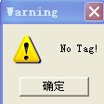
If the access password is wrong, then popup the below frame:
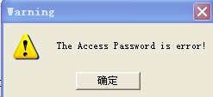
If the tag doesn’t have this function, will popup the below frame:
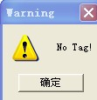

2.21 Release reading protection
Once the tag been reliefed protection, the information of EPC can be identify normally.
Remarks: keep only one tag in the radio frequency for reliefing
The first step, fill the access password, such as『AAAAAAAA』；
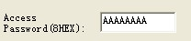
The second step, press『releif reading protect』button, reader send relief command to the tag, if success, popup the below frame:
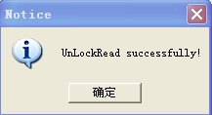
If reader found no tag, will popup the below frame:
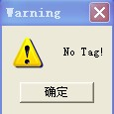
If the access password is wrong or the tag doesn’t have this function, then popup the below frame:
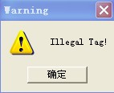

- The reading and writing test for ISO18000-6B tag
  - Program for reading and writing
If have to test functionality and performance of the reader, it can be made according to the following way operation. First introduce the operatin way for ISO18000-6B standard tag as below:
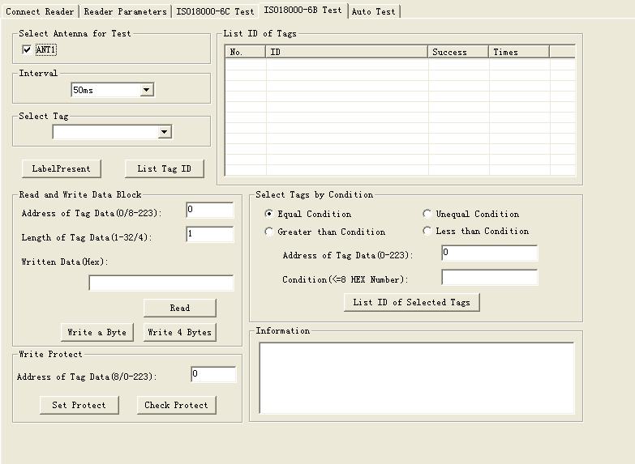
  - Identify all the tag ID
Operation steps as below:
Set antenna:
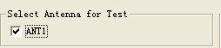
Press the 『List tag ID』button, and put tags in radiation field, reader keep to read tag ID of tag automaticly until pop-up 『List tag ID』button.The card number showed in the『List ID of Tags』frame as below:
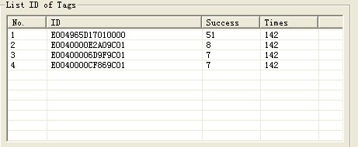
Remove the tag during the antenna radio frequency area can test the reading distance and range.
  - Read data
The start address of reading is 0-223.
The length range of reading block is 1-32.
The operating step for testing the reader’s『read』function is as below:
  - Select a tag which will be read from『select a tag』frame (this frame show the result of『list tag of ID』).
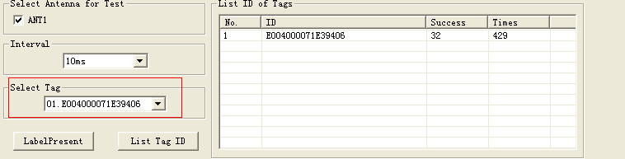
  - Select the initial address and block length of reading operaton. 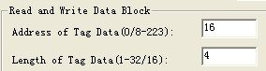
  - Press『read』button, the program will start repeatly read automaticly until pop-up this button.
  - The reading result showed at the『informaiton』.
Each line displayed the result of one reading operation, display with Hex firstly.
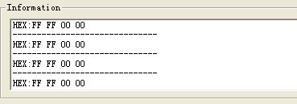
  - Write HEX
The initial address range of writing operation is 8-223.
The block length of writing operation is 1-4Bytes.
The operating step of test reader’s『write』function:
  - Select a tag which will write data from『written data』.
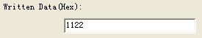
  - Input the initial address of writing operation.
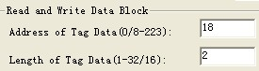
  - Press『write a Byte』button, the program will start repeat write data automaticly until pop-up the button.
  - Write success or not showed in the『informaiton frame』, see below.
  - 『write success！』represents this operation success.
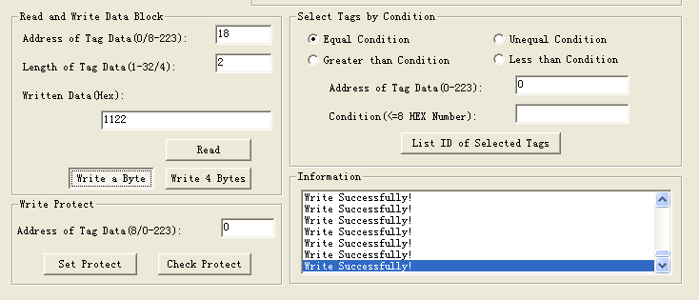
『write fail!』represents this operation failed, the reason is tag far from the reader too long or this bank write protection damaged.
Remarks: if the written data more than 4Bytes,『writen fail!』may due to patial bytes written failed.
  - Select Tags by Condition: users can select the coincident tag ,then click 『List ID of Selected Tags』button, the tags meet the conditions will be read and show in "List ID of Tags ", uncoincident don’t output not be read.
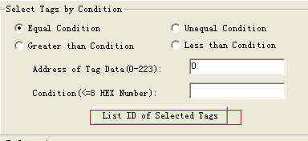
Example:Tag ID is E0040000128A8A01, input 4 to “Address of Tag Data” (0 ~ 233) And 06 in “Condition” , Check “Equal Condition” and click "List ID of selected Tags" button , There is nothing ouput on the "List ID of Tags" (because the start address is 4, reader compare the fourth BYTE of tag as to the condition. i.e., 12, and 12 is not equal to 6, and not meet the condition ,so that the tag is not able to read. If condition is 12,the ID meet it and be read. If the User choose “Unequal Condition” or “Greater than Condition”the tag ID be read. But “Less than Condistion” not, because the start address is 4 , in this tag ID mean 12, the condition is 06, 12 great and Unequal to 06.
  - Write protection
The operation step is as below:
  - Select a tag which will plan to protection from『select tag』.
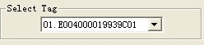
  - Add the address of the tag in 『Address of Tag Data』frame. The address range is 8-223. Such as
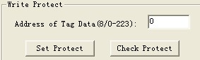
  - Press『set protect』button, see as below:
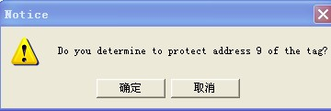
  - Press 『yes』, program will continue protect this tag. If failed, will popup the below dialogue frame:
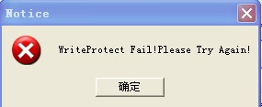
  - Press 『yes』,try again, protection success, will pop up the below dialog frame:
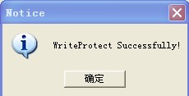
  - Detect the specified bank of the tag been protected or not (detect address range is 0-223). Press『detec the protection situation』button, pop up the below frame show that this specifed bank has been protected.
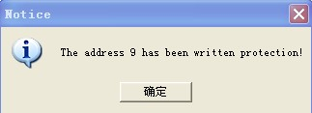
- Auto Test Setting
Remarks:
the belows only workable when connected with Upper PC
- Start or stop Auto work mode
- Clear memory
- Get Tag information
When turn to Auto mode, the former ID information will be clean
The auto settings should be checked before Auto work.
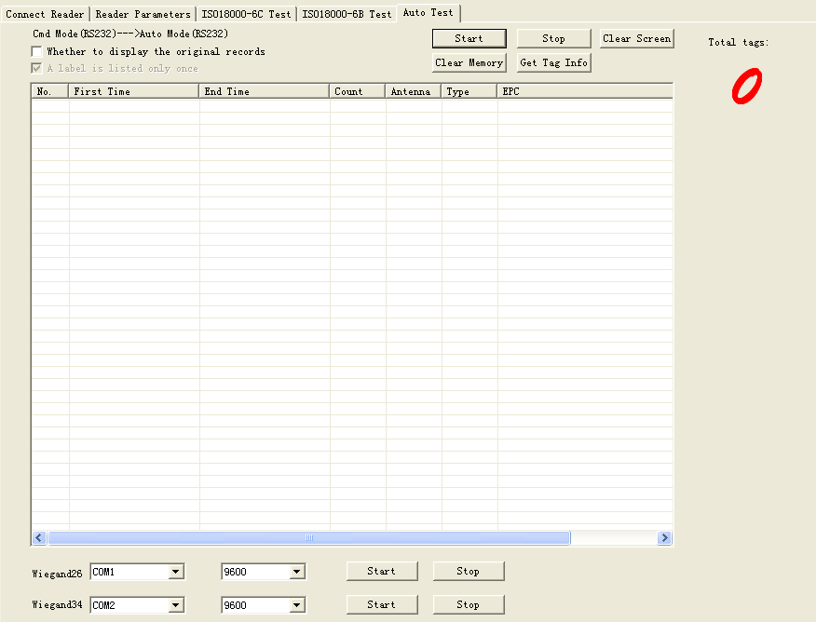
- Whether to display the original records: output the original ID info.
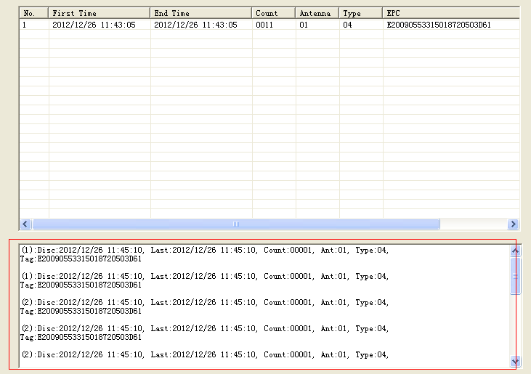
- A label is listed only once: tag can be read more times but output just a time
- Check Direct
- Check Direct in “Condition of Report”
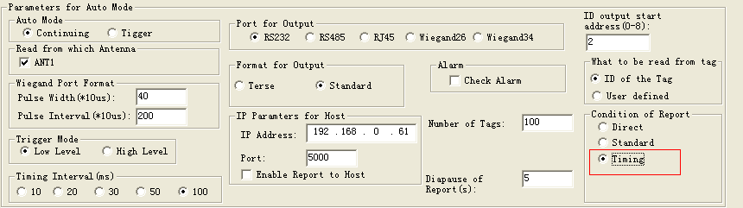
- Press “Start” in “Auto test”, turn out as below
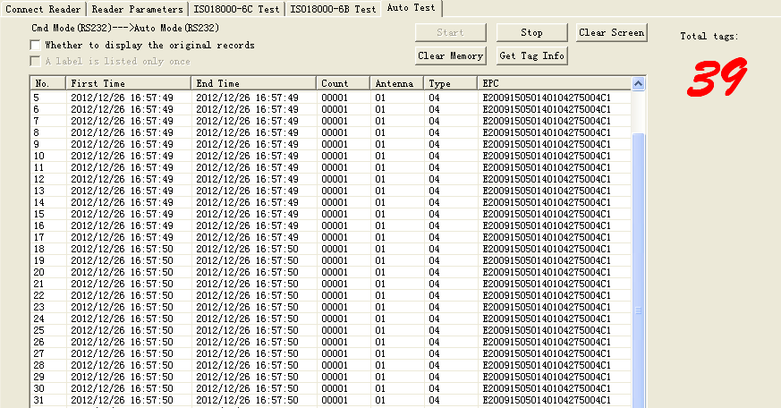
“First time”—the first time of reading this tag
“End time”- the last time of reading this tag
“Count”- During the time of reading counts
“Antenna”-from which antenna port
“Type”-Tag type
“EPC”- EPC Info
Read output the tag ID immerdiately once get it
- Press”Stop” stop reading
- “Get tag info” : Read send all storeage ID info to upper PC
- “Clear Memory”: Read clear all read info from storeage
- Check Standard
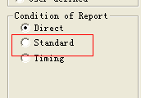
- Check Standard in “Condition of Report”
- Check the “Diapause of Report” as you want
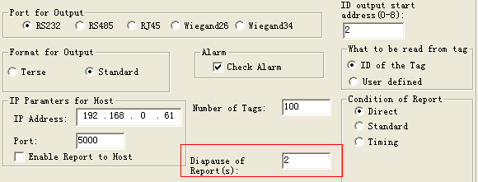
- Press “Start” in “Auto test”, turn out as below
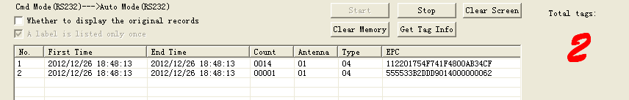
- Check Timing
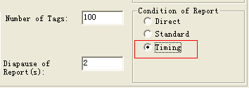
- Check Standard in “Reader Parameters”
- Check the “Diapause of Report” as you want
Output nothing when first read
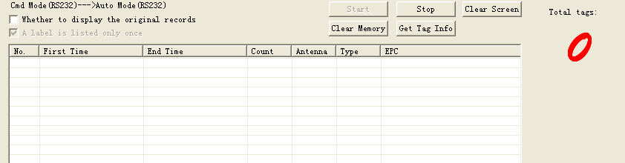
Put the tag out RF field for the time you setting, then put the tag in RF field, the tag ID be read and output
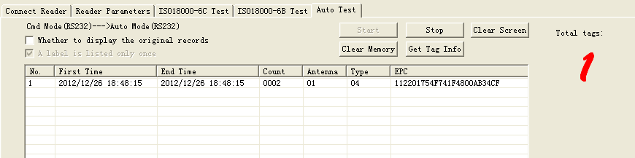
This function similar as bus swiping card

